ASSIGNMENT : 5

1.
Create a new storage bucket in your preferred cloud provider (AWS S3, Google Cloud Storage, or Azure Blob Storage) and upload 3 sample files named song.mp3, food.jpg, and bill.pdf, simulating files from apps like Spotify, Zomato, and Paytm.
ANS :
Steps :
Step 1: Open Amazon S3
Log in to the AWS Management Console and search for S3. Open the Amazon S3 service.
Step 2: Create a New Bucket
Click Create bucket and enter a unique bucket name. Select the required AWS Region, such as Asia Pacific (Mumbai) – ap-south-1. Keep the default security settings and click Create bucket.
Step 3: Open the Bucket
Open the newly created S3 bucket and go to the Objects section.
Step 4: Upload Files
Click Upload and select the three sample files from the computer:
- song.mp3
- food.jpg
- bill.pdf
Step 5: Complete the Upload
After selecting the files, click Upload and wait until AWS confirms that the files have been successfully uploaded.
Step 6: Verify the Files
Open the Objects section of the bucket and verify that all three files are displayed:
- song.mp3 – represents a Spotify audio file.
- food.jpg – represents a Zomato food image.
- bill.pdf – represents a Paytm bill/document.
Step 7: Take a Screenshot
Take a screenshot of the S3 Objects page showing all three uploaded files and add it to the assignment.
Result
The AWS S3 storage bucket was successfully created, and the three sample files (song.mp3, food.jpg, and bill.pdf) were successfully uploaded and stored in the cloud.

Screenshot : AWS S3 bucket containing the three uploaded sample files.
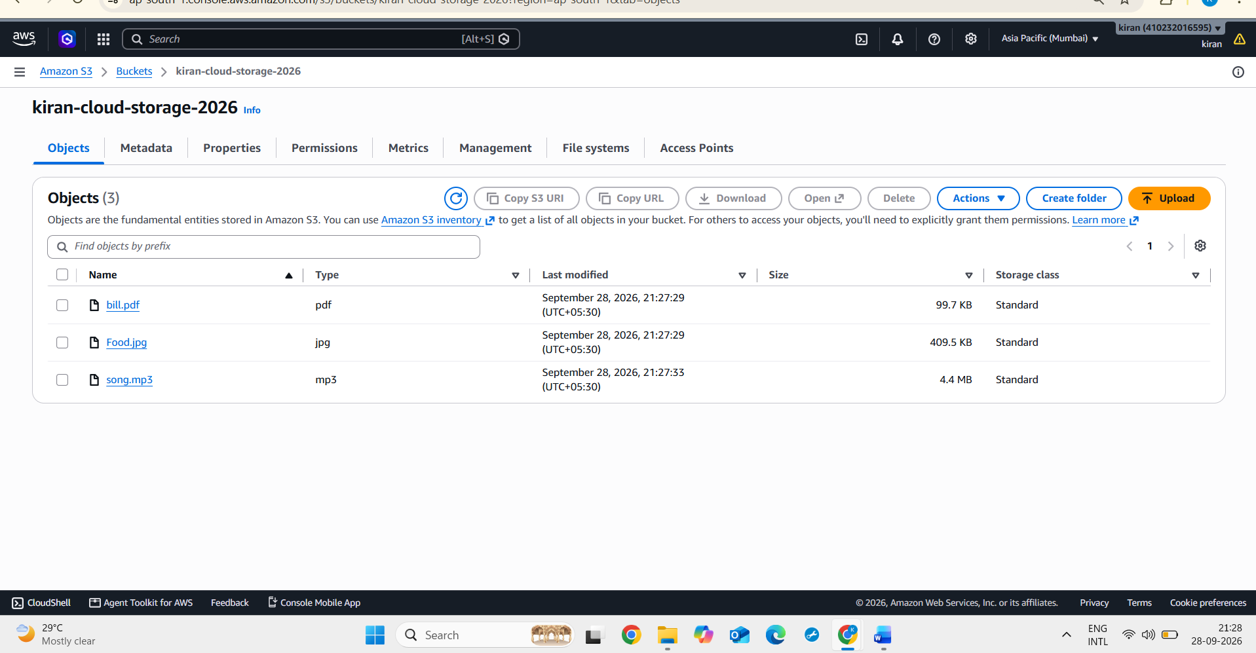

2.
Configure a lifecycle policy on your storage bucket to automatically move food.jpg to a cheaper storage class (like S3 Glacier, Google Coldline, or Azure Cool) after 1 day and delete bill.pdf after 3 days.<br><br><em><strong>Hint:</strong> Use your cloud provider's console or CLI to set up these rules, and double-check the transition and expiration actions.</em>
ANS :
Steps :
Step 1: Open the S3 Bucket
Logged in to the AWS Management Console and opened the S3 bucket containing song.mp3, food.jpg, and bill.pdf.
Step 2: Open Lifecycle Rules
Selected the Management tab of the S3 bucket and opened the Lifecycle rules section.
Step 3: Create the Lifecycle Rule for food.jpg
Clicked Create lifecycle rule and selected Limit the scope of this rule using one or more filters. The rule was configured specifically for food.jpg.
Step 4: Configure Storage Class Transition
Selected Transition current versions of objects between storage classes and configured food.jpg to transition to S3 Glacier Flexible Retrieval after 1 day.
Step 5: Create the Lifecycle Rule for bill.pdf
Created another lifecycle rule and limited its scope to bill.pdf.
Step 6: Configure Expiration
Selected Expire current versions of objects and configured bill.pdf to be automatically deleted 3 days after object creation.
Step 7: Verify the Rules
Checked the Lifecycle rules section to verify that both rules were created successfully.
Result
The S3 lifecycle policy was successfully configured. food.jpg is scheduled to move to the cheaper S3 Glacier Flexible Retrieval storage class after 1 day, while bill.pdf is scheduled for automatic deletion after 3 days.

Screenshot : S3 bucket lifecycle rules configured for food.jpg and bill.pdf.
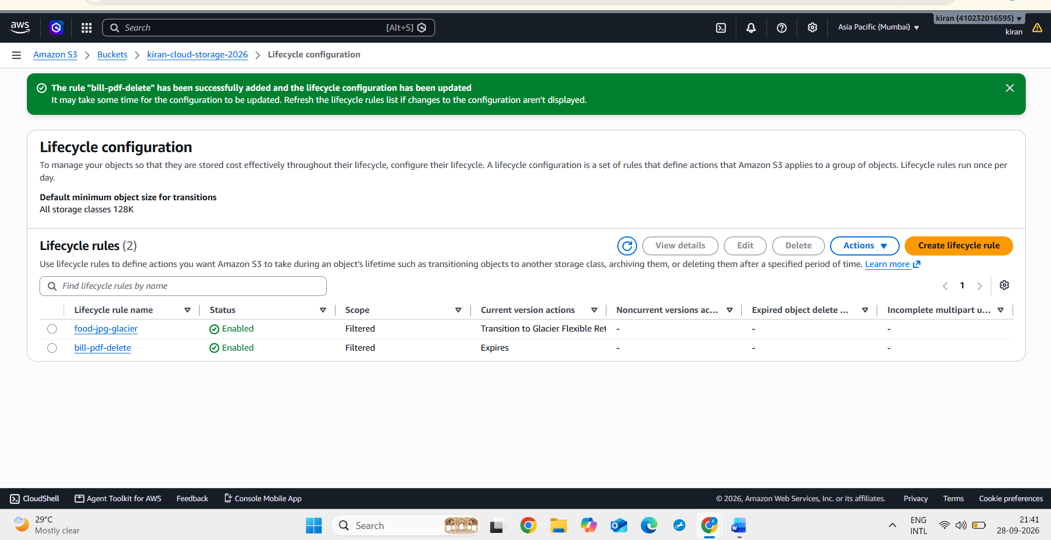
Screenshot : Lifecycle rule configured to transition food.jpg to S3 Glacier Flexible Retrieval after 1 day.
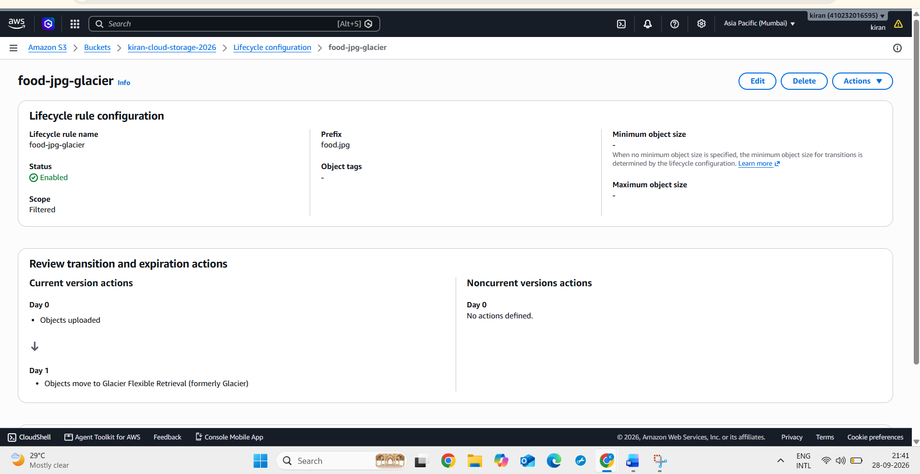
Screenshot : Lifecycle rule configured to automatically delete bill.pdf after 3 days.
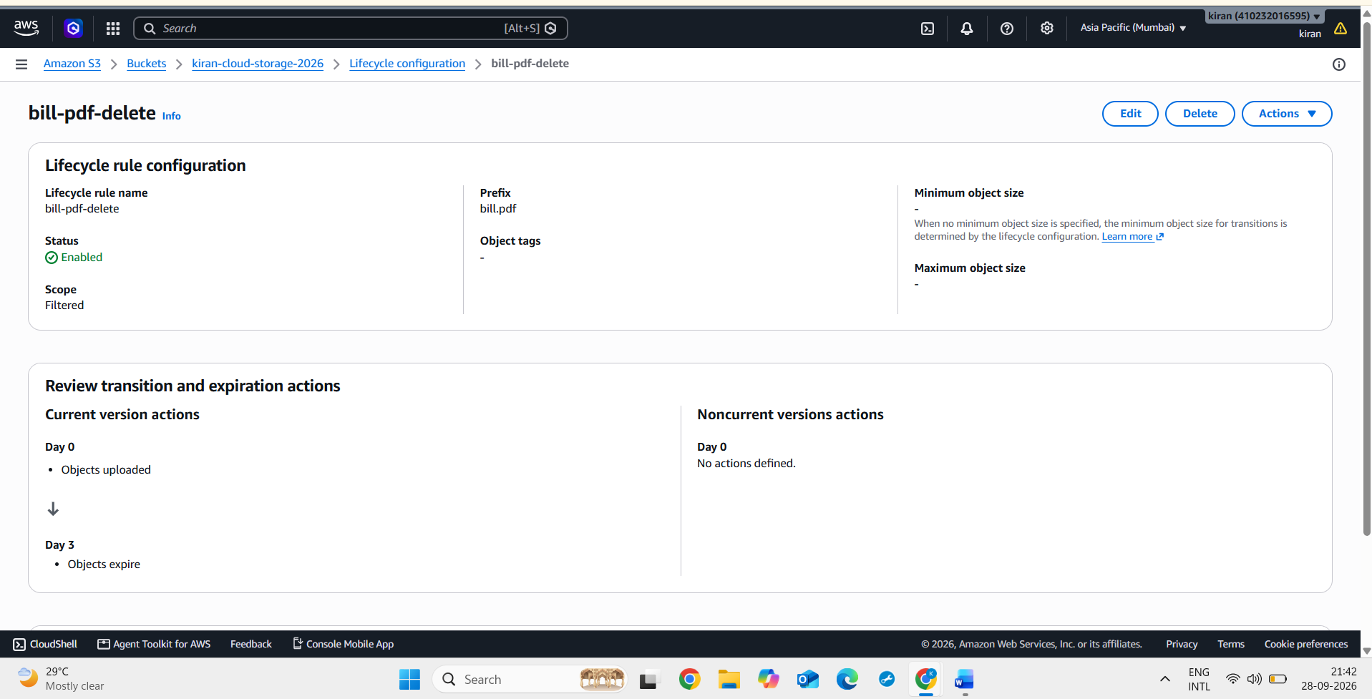
3.
Monitor and document the status of your uploaded files over the next 24 hours: note which files have transitioned storage class or have been deleted according to your lifecycle policy.<br><br><em><strong>Hint:</strong> Take a screenshot of the object details or use the CLI to confirm the changes.</em>
ANS :
Steps:
Step 1: Wait for the Lifecycle Period
Wait approximately 24 hours after configuring the S3 lifecycle rules before checking the status of the files.
Step 2: Open the S3 Bucket
Log in to the AWS Management Console, open Amazon S3, and select the bucket containing song.mp3, food.jpg, and bill.pdf.
Step 3: Check the Objects
Open the Objects section and check the current status of the uploaded files.
Step 4: Check food.jpg
Open food.jpg and view its object details. Check the Storage class field to determine whether the file has been transitioned to S3 Glacier Flexible Retrieval.
Step 5: Check bill.pdf
Check whether bill.pdf is still present in the bucket. Since its lifecycle rule is configured for deletion after 3 days, it should normally still be present after only 24 hours.
Step 6: Check song.mp3
Verify that song.mp3 remains in the bucket because no lifecycle rule was configured for this file.
Step 7: Record the Observations
Document the actual status of each file after the 24-hour observation period.
Observation Table
File | Lifecycle Action | Observation
Food.jpg | Transition to s3 Glacier Flexible Retrieval after 1 day | Check the storage class
Bill.pdf | Delete after 3 days | Should remain after 24 hours
Song.mp3 | No Lifecycle Action | Remains in the bucket

Step 8: Take Screenshots
Take screenshots of the S3 object details and Objects page to provide evidence of the observed status.
Result
The uploaded files were monitored after the configured lifecycle period, and their storage status was documented according to the lifecycle rules.
Screenshot : Lifecycle Rule Configuration Shows both Lifecycle Rules are Enabled.
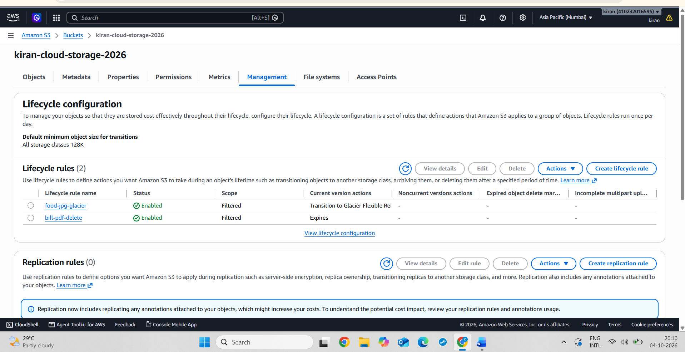
Screenshot : food-jpg-Glacier rule Details Showing Day 1 Glacier Flexible Retrival.
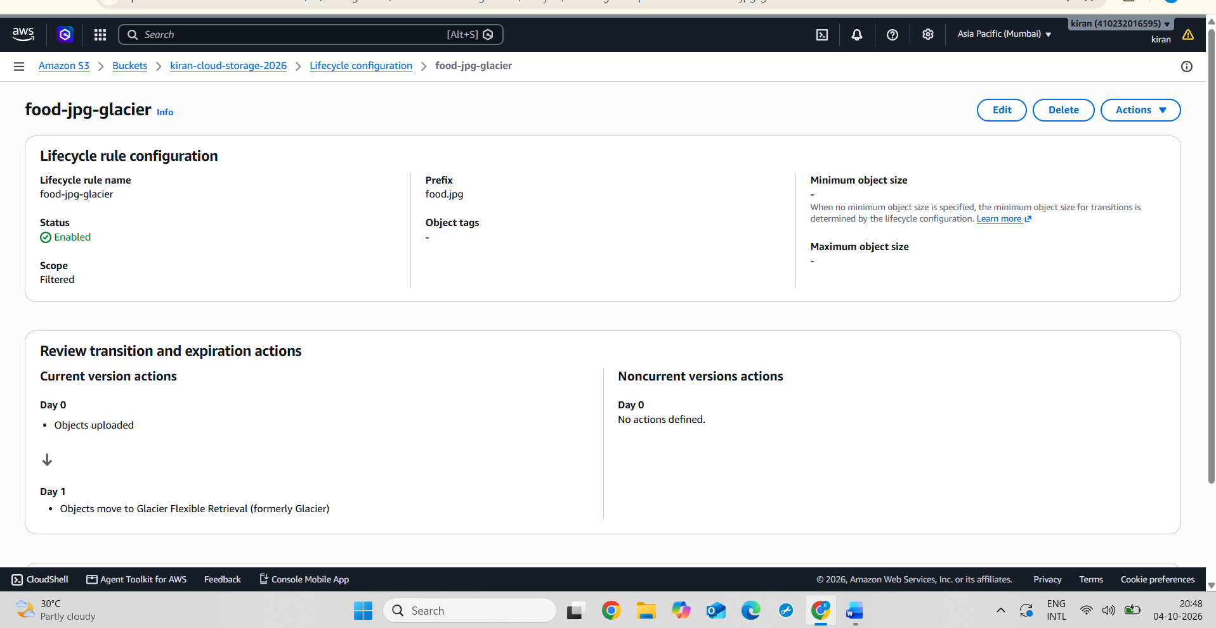
Screenshot : After the lifecycle period, bill.pdf was automatically deleted, while food.jpg and song.mp3 remain in the bucket.
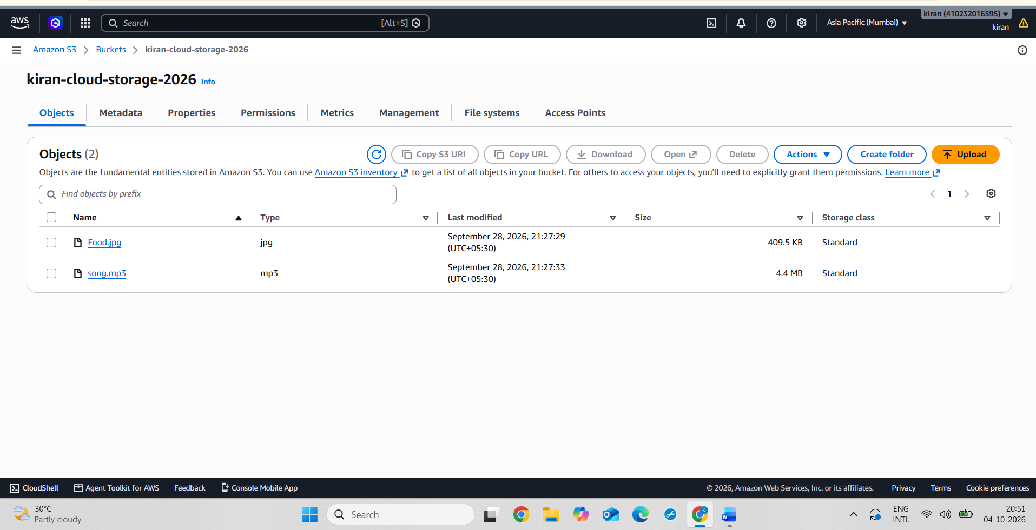
4.
Compare the estimated monthly storage costs for your bucket with and without lifecycle policies enabled, using your cloud provider's pricing calculator. Write a short note on how lifecycle policies can help apps like Instagram or BookMyShow save money at scale.
ANS :
Steps :
Step 1: Open the AWS Pricing Calculator website.
Step 2: Select Amazon S3 (Simple Storage Service) from the available AWS services.
Step 3: Select the Asia Pacific (Mumbai) region to match the S3 bucket region.
Step 4: Configure 5 GB of S3 Standard storage to calculate the estimated monthly cost without a lifecycle policy.
Step 5: Add the configuration to the estimate and note the estimated monthly storage cost.
Step 6: Create a second S3 cost configuration to represent the lifecycle policy scenario.
Step 7: Configure part of the storage as S3 Standard and part as S3 Glacier Flexible Retrieval, representing data that has been automatically moved to a cheaper storage class by the lifecycle policy.
Step 8: Add the second configuration to the estimate and note the estimated monthly cost with the lifecycle policy.
Step 9: Compare the two estimated monthly costs to determine the potential storage cost saving.
Step 10: Document the results and attach screenshots of both pricing calculator configurations to the assignment.
Conclusion
Lifecycle policies can help applications such as Instagram and BookMyShow reduce storage costs by automatically moving older or less frequently accessed data to lower-cost storage classes. They can also automatically delete data that is no longer required. At large scale, these automated storage-management rules can help control long-term cloud storage expenses.

Screenshot : AWS Pricing Calculator showing the estimated monthly cost of 5 GB S3 Standard storage without a lifecycle policy.

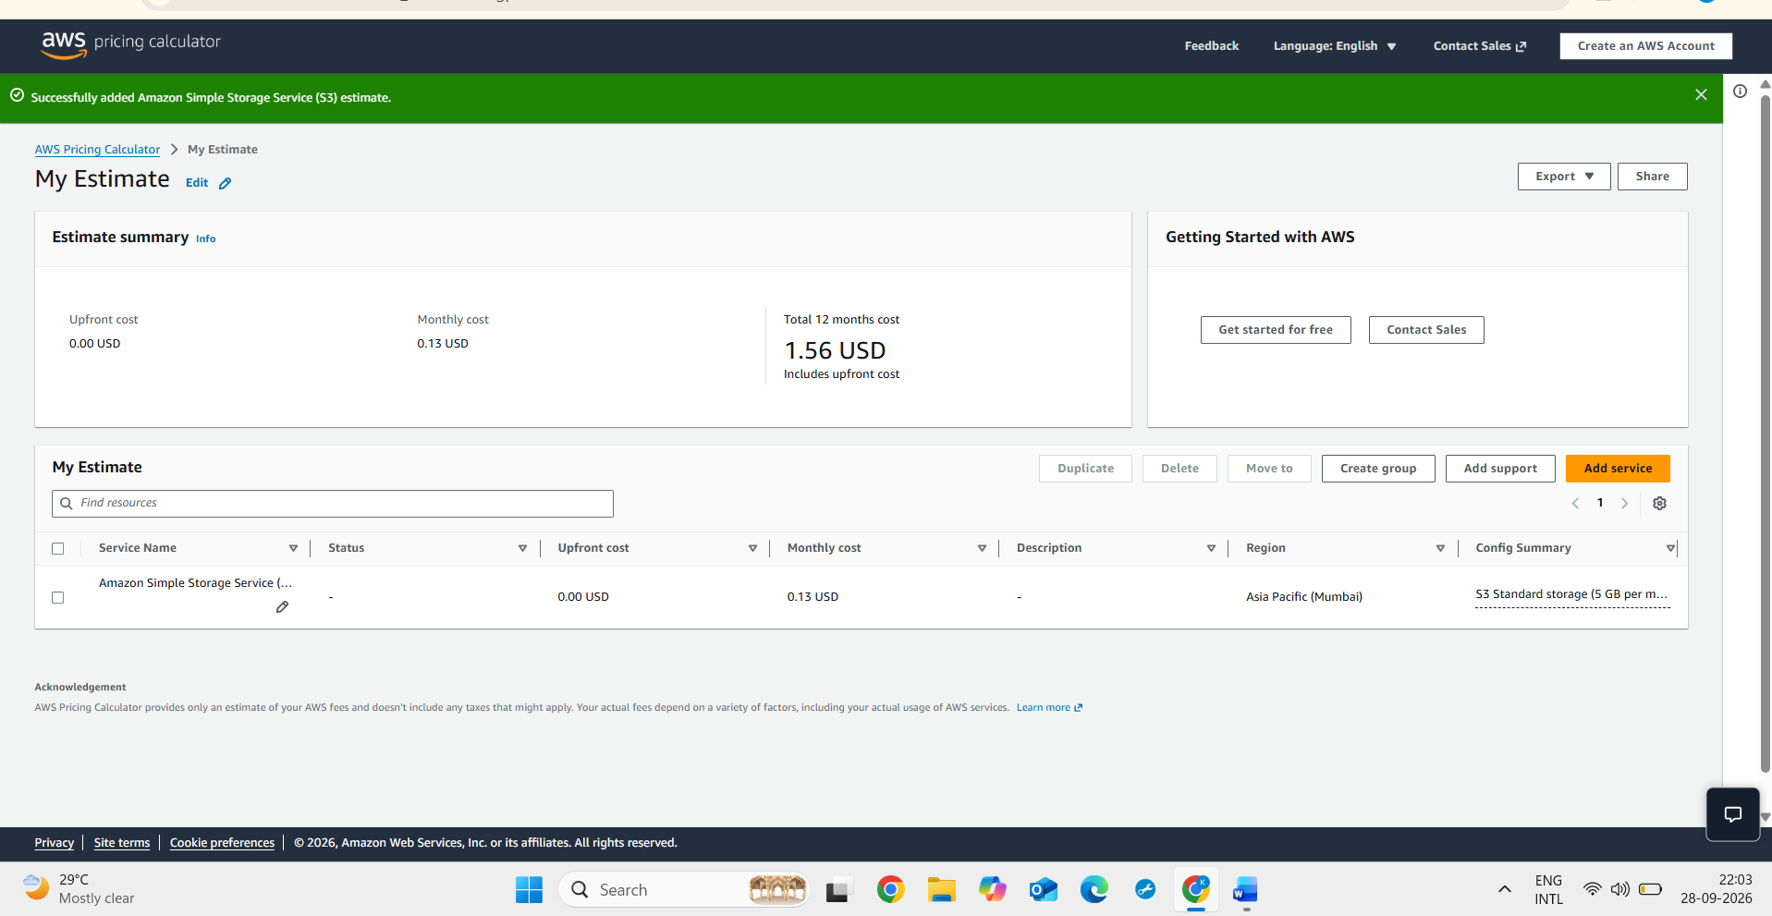
Screenshot : AWS Pricing Calculator showing the estimated monthly storage cost with lifecycle-based transition from S3 Standard to S3 Glacier Flexible Retrieval.
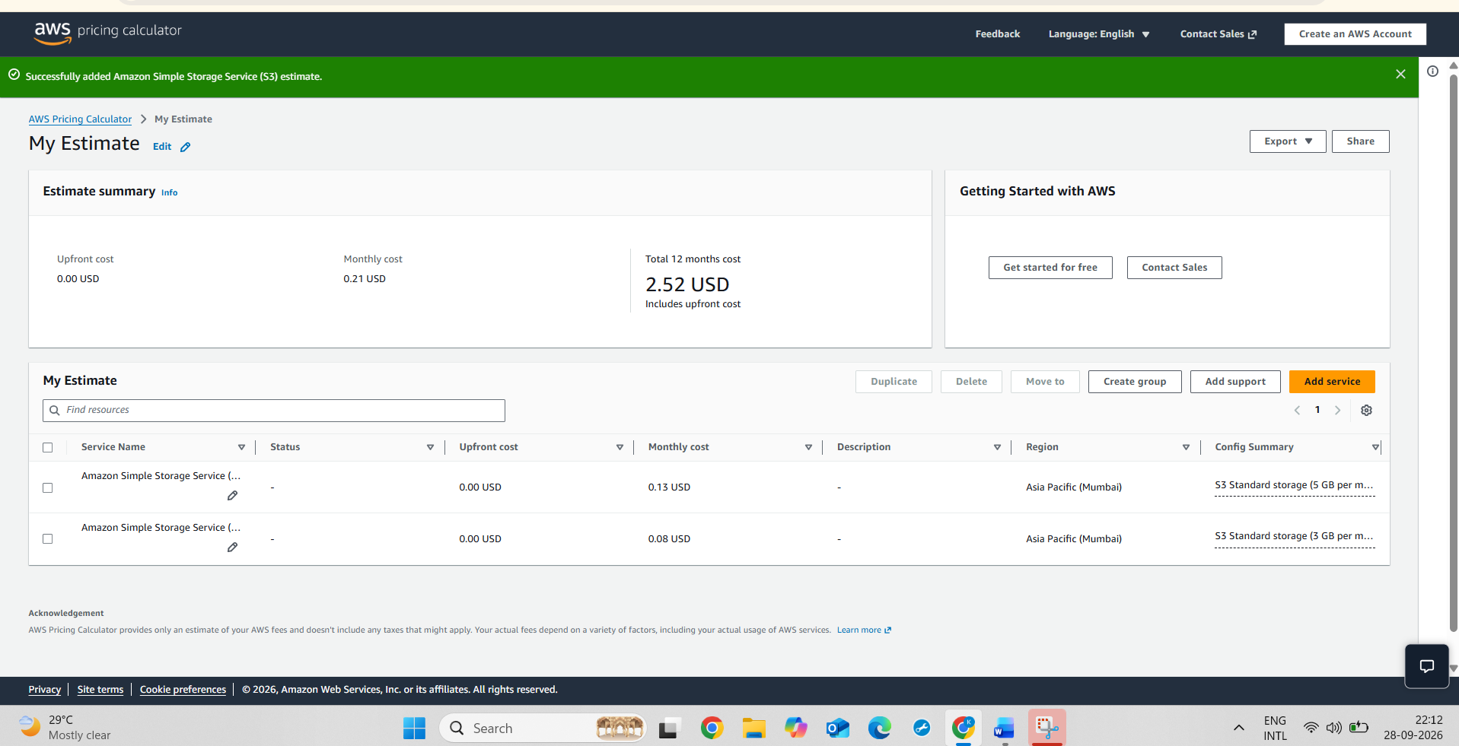

5.
Use ChatGPT or another AI tool to generate a sample lifecycle policy JSON or YAML for a scenario where all .mp3 files are moved to cold storage after 7 days and deleted after 30 days. Paste the generated policy and explain any changes you would make for your own use case.
ANS :
Generated Policy:
{
"Rules": [
{
"ID": "MP3-Cold-Storage-Policy",
"Status": "Enabled",
"Filter": {
"Tag": {
"Key": "filetype",
"Value": "mp3"
}
},
"Transitions": [
{
"Days": 7,
"StorageClass": "GLACIER"
}
],
"Expiration": {
"Days": 30
}
}
]
}
Explanation:
The policy identifies MP3 objects using the filetype=mp3 tag. After 7 days, the matching objects are transitioned to S3 Glacier Flexible Retrieval for lower-cost storage. After 30 days, the objects are automatically deleted.
Changes for My Own Use Case:
For my own use case, I would review the 30-day deletion period before applying the policy. If the MP3 files may be required for a longer period, I would increase the retention period. I would also consider the access frequency and retrieval requirements before moving files to Glacier storage.

